DMCC Office, 13E, Thirteenth Floor,  Almas Towers, Jumeirah Lakes Tower,  Dubai, United Arab Emirates | Phone: +971 58 595 2817  Email: ceo.aftradedmcc@gmail.com
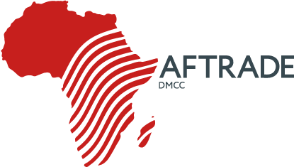
Check-list (Agriculture)

- What kind of crops do you plant?
- Which technology of planting is used?
- Which technology ofcrops harvesting is used?
- Which technology of fertilizing is used and what kind of fertiliz-ers are used?
- Is there any necessity in preparation of the soil? (de-bushing, plowing etc.)
- Will be interesting for you the fodder conservation for animals?
- Is there interest in technologies of feeding of animals?
- Is there a need in the preparation of solution regarding the stor-age of grain, maize, soya, sunflower? (is yes, fill in check-list 2)
- What power (h.p.) of tractor is preferable for you?
- Do you prefer canopy-frame, tent or cabin for tractor?
- Which drive is preferable for tractor?
- Do you need air conditioner in cabin?

